**FOREIGN TRADING SYSTEM**

***SEQUENCE DIAGRAM***

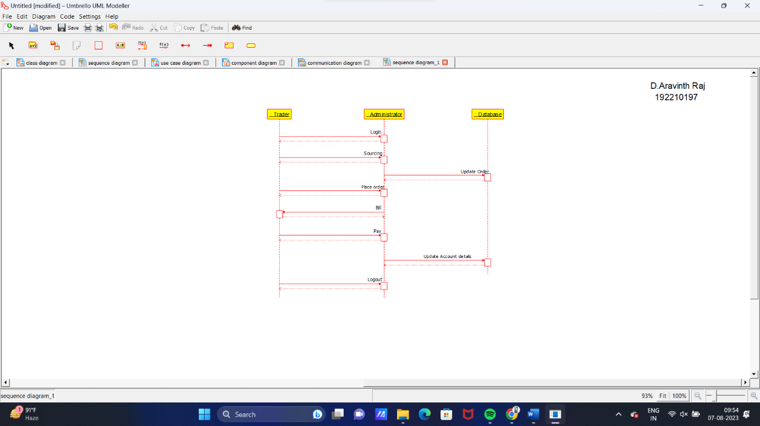

***USECASE DIAGRAM***

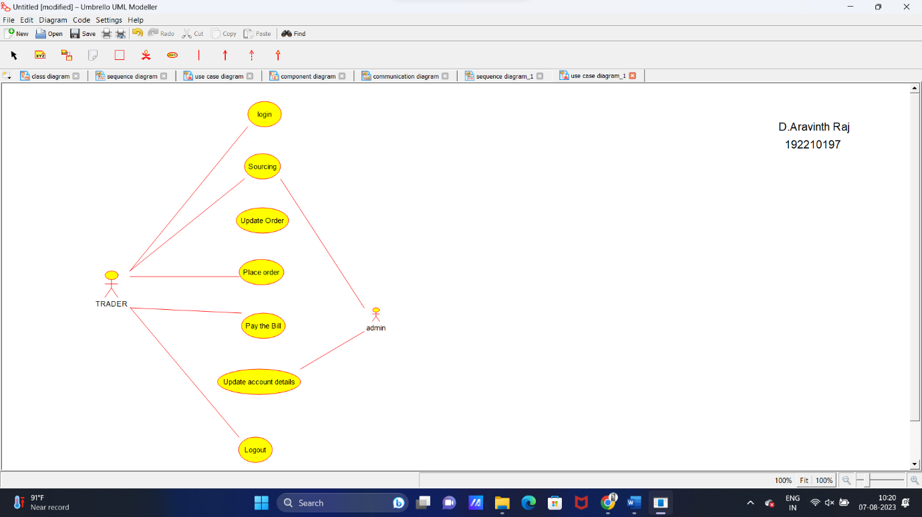

***COMPONENT DIAGRAM***

